

**Bank Marketing**

Project Report

on

**Bank Marketing**



REPORT SUBMITTED TO

VISHWAKARMA INSTITUTE OF INFORMATION TECHNOLOGY, PUNE

In Subject: **Multivariate Analysis**

By

|  |  |  |
| --- | --- | --- |
| **NAME** | **ROLL NO** | **PRN NO** |
| Aryan Dalvi | 371014 | 22320619 |
| Aditya Jasoriya | 371025 | 22320607 |
| Riya Shete | 371075 | 22320173 |
| Kalyani Bonde | 371076 | 22320196 |

Class : T.Y.B. Tech. Division: A

Guidance

**Prof. Gitanjali Yadav**

**Department of Artificial Intelligence and Data Science VIIT**

**INDEX**

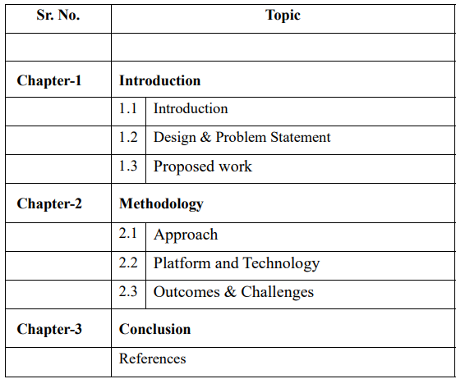

**Project Report on Bank Marketing**

**Chapter 1: Introduction**

**1.1 Introduction to the Topic**

In the evolving landscape of modern banking, customer acquisition and retention play a pivotal role in determining the success of financial institutions. Banks constantly seek to refine their marketing strategies to attract new customers and enhance the experience of existing ones. One such strategy involves the use of data-driven marketing campaigns aimed at encouraging customers to subscribe to financial products, such as term deposits.

The Bank Marketing System designed for this project leverages multivariate analysis to predict customer behaviour based on historical data from previous marketing campaigns. Specifically, this system focuses on direct marketing campaigns, where bank representatives directly contact customers, offering them financial products. The system analyzes various features of customers, including demographic information, financial data, and previous interactions with the bank, to predict the likelihood of a customer subscribing to a term deposit.

Through the application of machine learning techniques, the system builds a predictive model that aids the bank’s marketing team in optimizing resources, identifying promising leads, and improving campaign outcomes. The system is built using Python, leveraging several statistical and machine learning libraries for data processing, model building, and performance evaluation.

**1.2 Design and Problem Statement**

Traditional marketing strategies often involve a "one-size-fits-all" approach, resulting in inefficient resource allocation. Many campaigns target customers who are unlikely to respond positively, leading to wasted effort and suboptimal outcomes. Our system addresses this inefficiency by employing multivariate analysis techniques to provide accurate customer predictions, enabling targeted marketing.

1. To analyze customer data and identify the key variables that significantly influence the likelihood of subscribing to a term deposit.

2. To develop a predictive model using machine learning algorithms such as logistic regression, random forests, and support vector machines to classify customers based on their likelihood of subscribing.

3. To enable real-time predictions that provide actionable insights for marketing teams, allowing them to focus on the most promising customer leads.

The project is built around multivariate analysis techniques that incorporate several variables, ensuring robust predictions and actionable insights. The system design involves data preprocessing, feature engineering, model training, and performance evaluation to deliver an effective tool for the bank's marketing strategy.

**1.3 Proposed Work**

1. Data Collection and Preprocessing: Gathering historical customer data from previous direct marketing campaigns and ensuring it is clean, consistent, and ready for analysis. This involves handling missing values, removing outliers, and ensuring uniformity in data types.

2. Feature Selection and Engineering: Identifying the most influential features that impact customer behaviour , such as age, job status, and previous interaction history. Techniques such as Principal Component Analysis (PCA) and correlation analysis are used to select and engineer features that improve the model’s performance.

3. Predictive Modelling : Applying machine learning algorithms to build models that can predict customer responses to future marketing campaigns. Models such as logistic regression, decision trees, and support vector machines (SVM) are trained on historical data to classify customers as either likely or unlikely to subscribe.

4. Evaluation and Optimization: Testing the model using performance metrics like accuracy, precision, recall, and AUC (Area Under the Curve) to ensure it performs well on unseen data. Techniques such as hyperparameter tuning and cross-validation are applied to optimize the model for maximum performance.

**Chapter 2: Methodology**

**2.1 Approach**

1. Data Analysis: The system uses multivariate statistical techniques, including cross-tabulation, correlation analysis , and exploratory data analysis (EDA), to analyze the relationships between different customer attributes and their likelihood of subscribing to a term deposit.

2. Feature Selection: Variables such as age, income, job type, education, and previous loan status are examined to determine their relevance in predicting customer behaviour. Techniques like PCA are used to reduce dimensionality while retaining the most significant features.

3. Algorithm Selection: Based on the nature of the data, machine learning algorithms such as logistic regression, random forest, and SVM are chosen to build predictive models. These algorithms are well-suited for classification tasks and can handle both numerical and categorical data.

4. Model Training and Testing: The dataset is split into training and testing subsets, with the training set used to build the model and the testing set used to validate its performance. Techniques such as k-fold cross-validatio are used to ensure the model generalizes well to new data.

5. Performance Evaluation: Key metrics, including accuracy, precision, recall, and F1 score , are used to evaluate the model’s performance. Additionally, ROC curves are plotted to visualize the trade-off between true positives and false positives.

**2.2 Platform and Technology**

Pandas and NumPy: These libraries handle data manipulation, cleaning, and preprocessing. Pandas is used for tabular data structures, while NumPy handles numerical operations.

Scikit-learn: The core machine learning library used to build, train, and evaluate the predictive models. It provides a range of algorithms, including logistic regression, random forests, and support vector machines.

Matplotlib and Seaborn :These libraries are used for data visualization, helping to create graphs and charts that illustrate data distribution, correlations, and model performance.

Jupyter Notebooks: The development and testing of the models are done using Jupyter Notebooks, which allows for interactive programming, visualization, and documentation.

**Chapter 3: System Architecture**

**3.1. Structure**

The dataset used by the system is structured in a tabular format, where each row represents a unique customer and each column represents specific attributes, including:

Demographics: Age, job type, marital status, education level.

Financial Data: Account balance, previous loan status, income level.

Campaign Interaction Data: Contact duration, number of previous contacts, response to previous campaigns (success or failure).

**3.2 Algorithm Design**

The system employs several machine learning algorithms, with each designed to handle the classification task of predicting whether a customer will subscribe to a term deposit:

Logistic Regression: A statistical model used to estimate the probability of a customer subscribing to a term deposit based on multivariate inputs.

Random Forest: An ensemble learning method that builds multiple decision trees and outputs the majority class. This algorithm is robust to overfitting and handles complex interactions between variables.

Support Vector Machines (SVM): A supervised learning algorithm that finds the optimal hyperplane to separate customers into different classes (subscribing vs. non-subscribing).

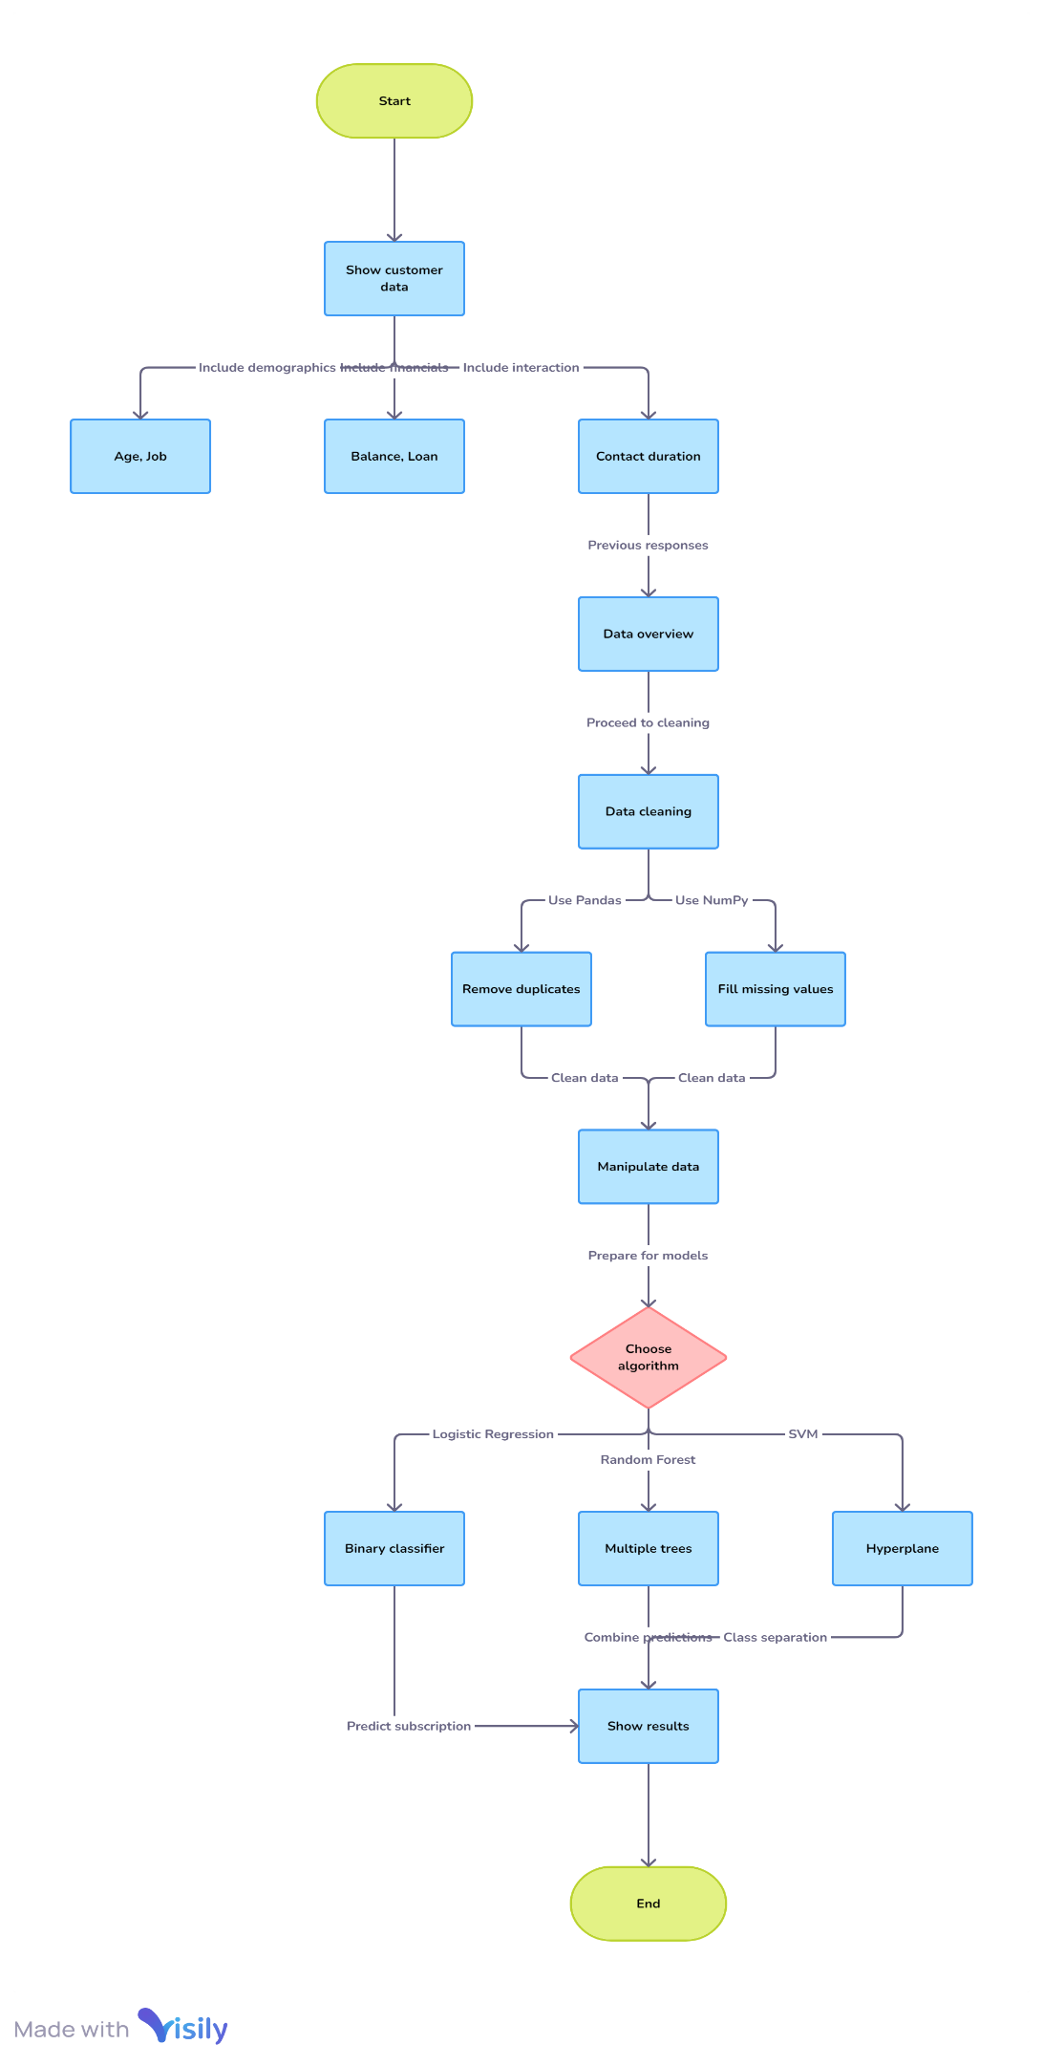

**Chapter 4: Functionality**

**4.1 Data Preprocessing**

Data preprocessing involves several steps to ensure the data is clean, consistent, and ready for model training:

-Handling Missing Values: The system fills in missing values using imputation techniques or removes rows with incomplete data.

- Feature Scaling: Numerical features are standardized using techniques such as Min-Max scaling or z-score normalization to ensure that they contribute equally to the model’s predictions.

**4.2 Model Training and Prediction**

Once the data is preprocessed, the system trains multiple machine learning models:

- Model Training: The system trains each model on historical customer data, with the training labels indicating whether the customer subscribed to a term deposit.

- Real-time Predictions: The system is capable of providing real-time predictions for new customers by feeding their attributes into the trained model.

**4.3 Evaluation Metrics**

- Accuracy and Precision: Measures how well the model predicts customer behaviour and minimizes false positives.

- ROC Curve: The system generates Receiver Operating Characteristic (ROC) curves to visualize the model’s ability to distinguish between customers who are likely and unlikely to subscribe.

**Chapter 5: Outcomes and Challenges**

**5.1 Outcomes**

The bank marketing system delivers several key outcomes, including:

- Efficient Targeting: The system allows the marketing team to focus on customers who are more likely to subscribe to a term deposit, improving the return on investment (ROI) for marketing campaigns.

- Reduced Campaign Costs: By targeting high-potential leads, the bank can reduce costs associated with unsuccessful marketing efforts.

- Improved Customer Retention and Acquisition: The system’s accurate predictions help the bank acquire new customers and retain existing ones through targeted offers and campaigns.

**5.2 Challenges**

Several challenges were encountered during the development of the system:

- Data Imbalance: The dataset was imbalanced, with far more customers not subscribing than subscribing. Techniques such as SMOTE (Synthetic Minority Over-sampling Technique) were used to address this issue by balancing the classes.

-Model Overfitting: Careful attention was paid to ensure the model did not overfit the training data. Regularization techniques such as L2 regularization were applied to improve the model’s generalization capabilities.

**Chapter 6: Conclusion**

The Bank Marketing System developed using multivariate analysis and machine learning demonstrates the power of data-driven decision-making in optimizing marketing campaigns. By predicting customer behaviour with high accuracy, the system provides valuable insights that help the bank allocate resources more efficiently. Future work could involve expanding the system to a web-based platform or integrating real-time customer data to enable dynamic predictions.

**References**

Hastie, T., Tibshirani, R., & Friedman, J. (2009). *The Elements of Statistical Learning: Data Mining, Inference, and Prediction* (2nd ed.). Springer.

James, G., Witten, D., Hastie, T., & Tibshirani, R. (2013). *An Introduction to Statistical Learning with Applications in R*. Springer.

Bishop, C. M. (2006). *Pattern Recognition and Machine Learning*. Springer.

Pedregosa, F., Varoquaux, G., Gramfort, A., et al. (2011). *Scikit-learn: Machine Learning in Python*. Journal of Machine Learning Research, 12, 2825-2830.

Zou, H., & Hastie, T. (2005). *Regularization and Variable Selection via the Elastic Net*. Journal of the Royal Statistical Society: Series B (Statistical Methodology), 67(2), 301-320.

Breiman, L. (2001). *Random Forests*. Machine Learning, 45(1), 5-32.

Cortes, C., & Vapnik, V. (1995). *Support-Vector Networks*. Machine Learning, 20(3), 273-297.

Friedman, J. H. (2001). *Greedy Function Approximation: A Gradient Boosting Machine*. Annals of Statistics, 29(5), 1189-1232.